**Industrial automation using IoT with data monitoring and controlling**

**Table of contents:**

|  |  |  |
| --- | --- | --- |
| **S.no** | **Content** | **Page.no** |
| **1** | **About Industrial automation using IoT with data monitoring and controlling** | **2** |
| **1.1** | **Introduction** | **2** |
| **1.2** | **Abstract** | **2** |
| **1.3** | **Identifying features** | **2** |
| **1.4** | **State of art** | **3** |
| **2** | **Requirements** | **3** |
| **2.1** | **High level requirements** | **3** |
| **2.2** | **Low level requirements** | **3** |
| **2.3** | **SWOT analysis** | **4** |
| **2.4** | **5W's and 1H** | **4** |
| **3** | **Block diagram & explanation** | **5** |
| **3.1** | **block diagram of transmitter** | **5** |
| **3.2** | **block diagram of receiver** | **5** |
| **3.3** | **Sensors** | **6** |
| **3.4** | **Actuators** | **6** |
| **4** | **Structural diagram** | **8** |
| **5** | **Behavioural diagram** | **9** |
| **6** | **Flow chart** | **10** |
| **7** | **Simulation** | **10** |
| **8** | **Applications** | **13** |
| **9** | **Conclusion** | **13** |

**1. About Industrial automation using IoT with data monitoring and controlling:**

**1.1 Introduction:**

* Automation is one of the increasing needs with in industries as well as for reduces the human efforts by replacing the human efforts by system which are self-operated, The Internet is one way of the growing plat from for automation, through which new advancement are made through which on easily monitor as well control the system using internet.
* As in this project making use of Internet the system becomes secured and live data monitoring is also possible using IoT system. Within industries the various hazardous gases is being processed, hence to provide security to those employ working within those industries, it becomes important issue to work on their security, if leakage of gas takes place then these system alerts by turning ON alarm which notifies the employers.
* This system also helps us take some crucial decision from any point of the world within internet network. Wi-Fi shield is being used to act as service point between network and connecting network.

**1.2 Abstract:**

* Automation is one of the increasing needs with in industries as well as for reduces the human efforts by replacing the human efforts by system which are self-operated, The Internet is one way of the growing plat from for automation, through which new advancement are made through which on easily monitor as well control the system using internet. As in this project making use of Internet the system becomes secured and live data monitoring is also possible using IoT system. Within industries the various hazardous gas is being processed, hence to provide security to those employ working within those industries, it becomes important issue to work on their security, if leakage of gas takes place then these system alerts by turning ON alarm which notifies the employers. This system also helps us take some crucial decision from any point of the world within internet network. Wi-Fi shield is being used to act as service point between network and connecting network.

**1.3 Identifying features:**

* The IR sensor counts the number of products manufactured in the industries.
* The temperature sensor senses the real-time temperature with humidity of products manufactured to find out the fault products.
* The inductive proximity detects the metal movement and is interfaced with Adriuno to detect the machine processing count.
* Output measurements and required values shall be displayed in LCD.

**1.4 State of art:**

* The main goal of the project is to clarify management issues.
* Automated data collection in real time system.
* To reduce the manual observation of machine process.
* To reduce the manual observation of machine process.
* The data acquisition is automatically monitored in excel system.
* The data is analysed in ESP8266 and also stored in database.

**2. Requirements:**

**2.1 High level requirements:**

| **HLR** | **Description** |
| --- | --- |
| HLR_01 | This shall monitor the temperature |
| HLR_02 | This shall monitor the humidity |
| HLR_03 | This shall monitor the counting |

**2.2 Low level requirements:**

| **LLR** | **HLR** | **Description** |
| --- | --- | --- |
| LLR_01 | HLR_01 | This shall observe the temperature of parameter |
| LLR_02 | HLR_01 | The observed parameters are displayed in PC using Wi-Fi module |
| LLR_03 | HLR_02 | This shall observe the humidity of parameters of industry |
| LLR_04 | HLR_02 | The observed Para meters are displayed in PC using Wi-Fi module |
| LLR_05 | HLR_03 | This shall observe the number equipment. |
| LLR_06 | HLR_03 | The monitored number of equipment displayed on PC using Wi-Fi |

**2.3 SWOT analysis:**

[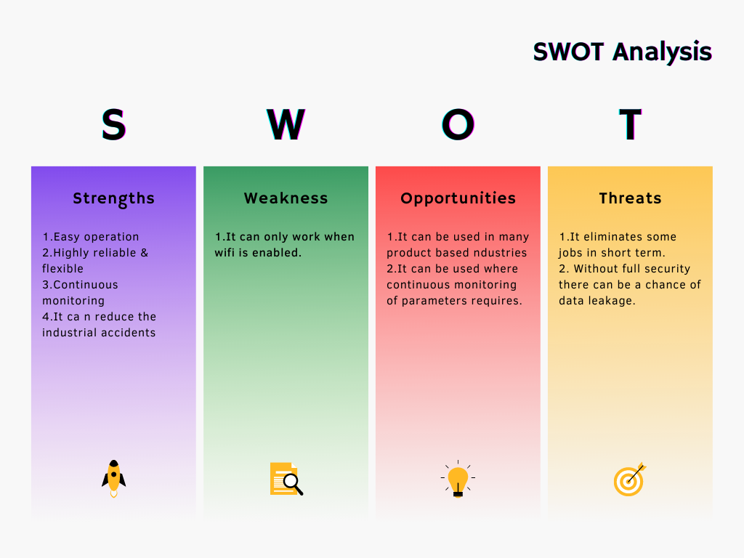](https://user-images.githubusercontent.com/98894505/156933099-2321adea-9ae0-4c84-a369-6618bc4557a6.png)

**2.4 5W's and 1H:**

[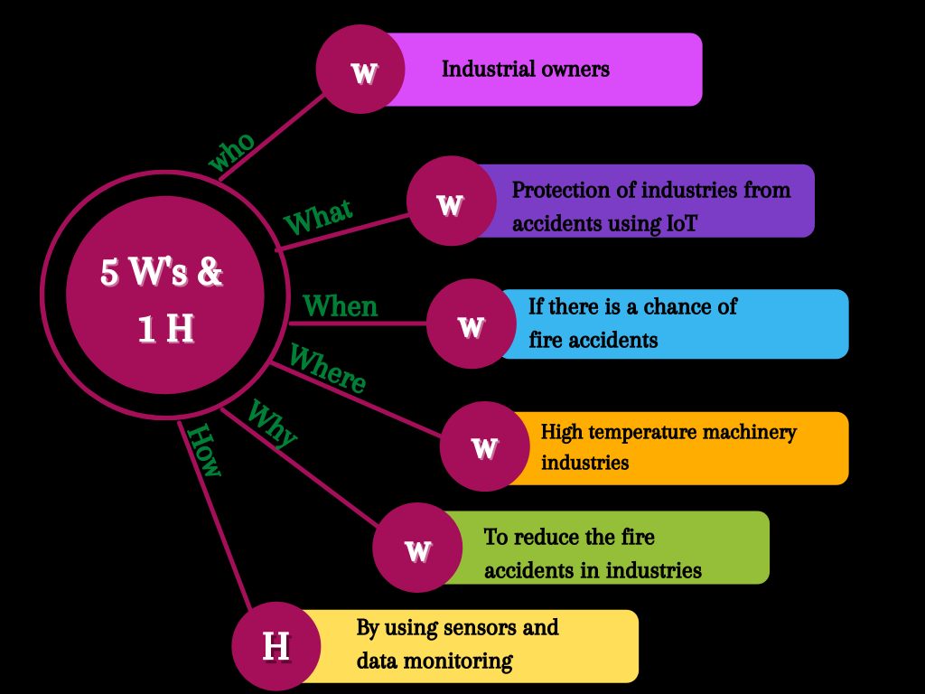](https://user-images.githubusercontent.com/98894505/156940722-db95b62f-de44-4487-9cee-1d3ebdf1eaf2.png)

# 3. Block diagram and explanation:

## 3.1 block diagram of transmitter:

[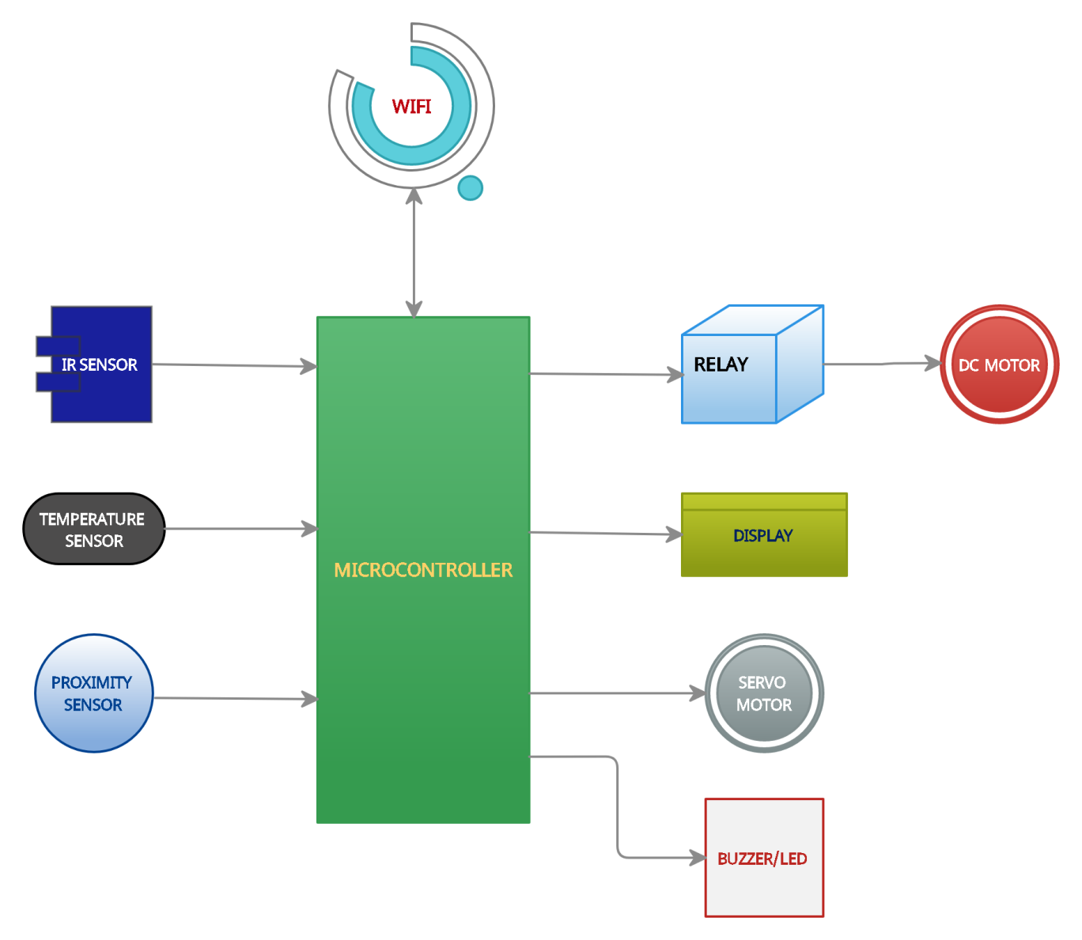](https://user-images.githubusercontent.com/98894505/155832250-28a10bb4-6a06-4893-b8ae-992a323f4fd9.jpg)

## 3.2 block diagram of receiver:

[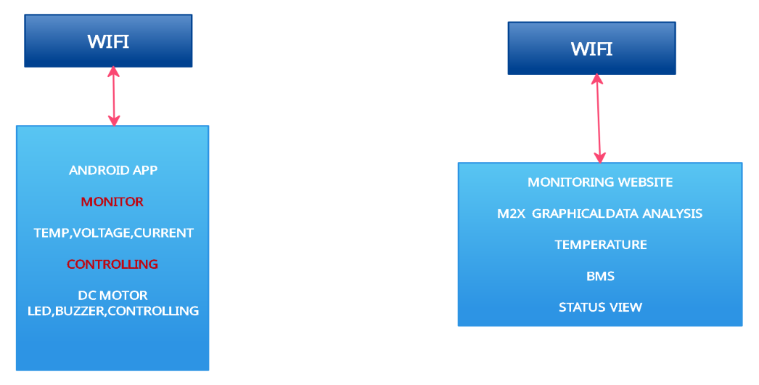](https://user-images.githubusercontent.com/98894505/155832356-38b51b3f-4279-45a1-87ff-d764dc221093.jpg)

## 3.3 Sensors:

### Sensor (IR sensor):

* Infrared IR detectors are specially filtered for infrared light; they are not good at detecting visible light.
* In a defined angle range, the sensor elements detect the heat radiation (infrared radiation) that changes over time and space due to the movement of people.
* The main benefits of IR sensors are low power usage, their simple design & their convenient features.
* IR signals are not noticeable by the human eye. The IR radiation in the electromagnetic spectrum can be found in the regions of the visible & microwave.

### Temperature sensor (thermistor):

* Temperature sensor will detect temperature or heat.
* Temperature sensors measure the amount of heat energy or even coldness that is generated by an object or system, allowing us to “sense” or detect any physical change to that temperature producing either an analogue or digital output.

### Proximity sensor:

* A proximity sensor is a sensor which detects the presence of nearby objects without any physical contact.
* This can be done using the electromagnetic field or electromagnetic radiation beam in which the field or return signal changes in the event of the presence of any object in its surrounding.
* It can detect both metallic and non-metallic objects, including liquid, powders, and granular elements.

## 3.4 Actuators:

### LCD display with i2c:

* It is much easier to connect an i2c lcd than to connect a standard lcd. You only need to connect 4 pins instead of 12.
* Start by connecting vin pin to the 5v output on the arduino and connect gnd to ground. Now we are remaining with the pins that are used for i2c communication.
* Each arduino board has different i2c pins which should be connected accordingly. On the arduino boards with the r3 layout, the sda (data line) and scl (clock line) are on the pin headers close to the aref pin. They are also known as a5 (scl) and a4 (sda).

### Relay:

* Relay is an electrically operated switch. It consists of a set of input terminals for a single or multiple control signals, and a set of operating contact terminals.
* The switch may have any number of contacts in multiple contact forms, such as make contacts, break contacts, or combinations.
* Relays are used where it is necessary to control a circuit by an independent low- power signal, or where several circuits must be controlled by one signal. Relays were first used in long-distance telegraph circuits as signal repeaters.
* They refresh the signal coming in from one circuit by transmitting it on another circuit.
* Relays were used extensively in telephone exchanges and early computers to perform logical operations.

### Servo motor:

* All motors have three wires coming out of them. Out of which two will be used for supply (positive and negative) and one will be used for the signal that is to be sent from the mcu. Servo motor is controlled by pwm (pulse with modulation) which is provided by the control wires.
* There is a minimum pulse, a maximum pulse and a repetition rate.
* Servo motor can turn 90 degree from either direction form its neutral position.
* The servo motor expects to see a pulse every 20 milliseconds (ms) and the length of the pulse will determine how far the motor.
* For example, a 1.5ms pulse will make the motor turn to the 90° position, such as if pulse is shorter than 1.5ms shaft moves to 0° and if it is longer than 1.5ms than it will turn the servo to 180°.

### Dc motor:

* An electric motor operated by dc (direct current) is known as a dc motor (unlike an induction motor that operates via an alternating current).
* A dc motor converts dc electrical energy into mechanical energy.
* Dc motors take electrical power through direct current, and convert this energy into mechanical rotation.
* Dc motors use magnetic fields that occur from the electrical currents generated, which powers the movement of a rotor fixed within the output shaft.
* The output torque and speed depends upon both the electrical input and the design of the motor.

### Buzzer / led:

### Buzzer*:*

* Buzzer is an electrical device that makes a buzzing noise and is used for signalling.

#### Led:

* It is a semiconductor diode that emits light when conducting current and is used in electronic displays, indoor and outdoor lighting, etc.
* It converts electrical energy directly into light, delivering efficient light generation with little-wasted electricity.

# 4. Structural diagram:

[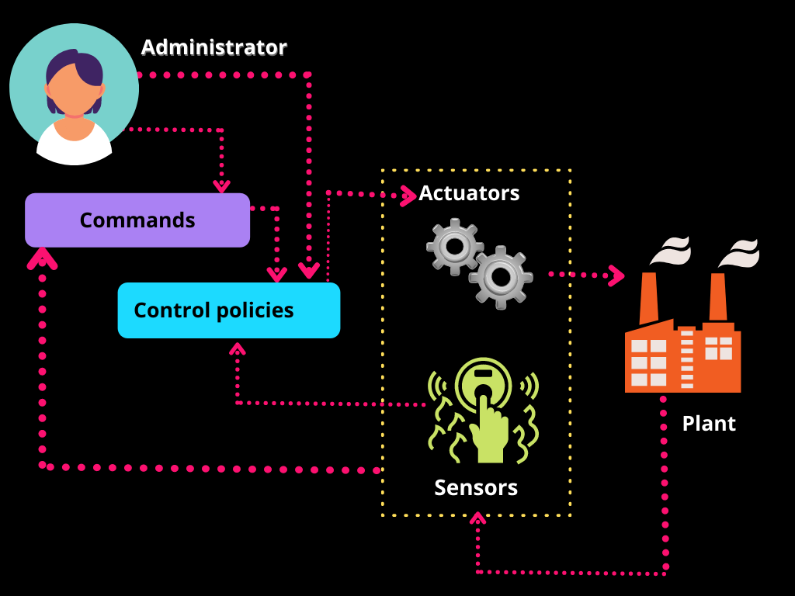](https://user-images.githubusercontent.com/98894505/157175808-01026a65-d06c-4609-aaee-c7c2fd5e9128.png)

# 5. Behavioural diagram:

[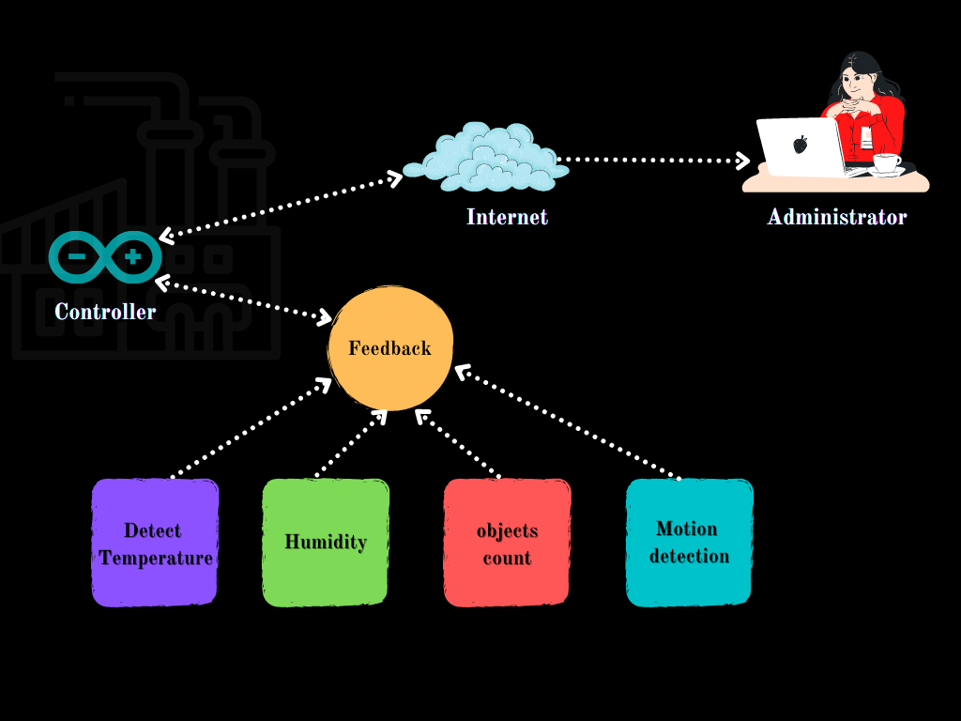](https://user-images.githubusercontent.com/98894505/157173143-e192eb18-d3e7-47c3-903e-ea1cbf7aa155.png)

# 6. Flow chart:

# [Untitled Diagram drawio (1)](https://user-images.githubusercontent.com/98894505/157110463-d3927d16-351f-46d9-b689-bf13cb577067.png)

# 7. Simulation:

# Simulation of this project is done in SimulIDE software which is a real time electronics circuit simulator. By using this we can simulate simple electronic circuits and microcontrollers, supporting PIC, AVR and Arduino. Simplicity and ease of use are the key features of this simulator. You can create, simulate and interact with your circuits within minutes, just drag components from the list, drop into the circuit, connect them and push power button to see how it works. SimulIDE also features a code Editor and Debugger for GcBasic, Arduino, PIC asm and AVR asm. It is still in its firsts stages of development, with basic functionalities, but it is possible to write, compile and basic debugging with breakpoints, watch registers and global variables.

# C:\Users\nandh\Downloads\1 (1).PNG

# C:\Users\nandh\Downloads\2 (1).PNG

# C:\Users\nandh\Downloads\3 (1).PNG

# C:\Users\nandh\Downloads\4 (1).PNG

# C:\Users\nandh\Downloads\5 (1).PNG

# 8. Applications:

* This system can be used in product manufacturing industry.
* This system can be used in packing machinery industries.
* This system will detect temperature automatically in industries. So it will prevent the explosion and fire accident which can cause by current leakage.

**9. Conclusion:**

In industrial manufacturing process, it is extremely important that process should be completed fast and safely besides product quality. Therefore, the communications between units are developing day by day in nowadays- industrial automation systems. These developments that mostly depending on usage of protocol are shown data transmission rate and security. In industrial automation systems, safe and high-speed internet connection is an important two factors for production process. The Wi-Fi technology brings safety connection. This fact might lead to more application fields for future work.in current wireless communication system has a security gap because radio waves can pass through the walls. Security gap is a big disadvantage for industrial automation systems that are working in higher-up security level. Light waves cannot pass through the walls. Therefore, these industrial automation systems are protected using Wi-Fi technology.